**63.1. Spring REST - CRUD Database Real-Time Project – Overview**

**API Requirements**:

Create a REST API for the Customer Relationship Management (CRM) system. REST clients should be able to

* Get a list of customers
* Get a single customer by id
* Add a new customer
* Update a customer
* Delete a customer

**Real-Time Project**:

|  |  |  |
| --- | --- | --- |
| **HTTP Method** | **API End Points** | **CRUD Action** |
| POST | api/customers | Create a new customer |
| GET | api/customers | Read a list of customers |
| GET | api/customers/ {customerId} | Read a single customer |
| PUT | api/customers | Update an existing customer |
| DELETE | api/customers/ {customerId} | Delete an existing customer |

**Application Architecture**:

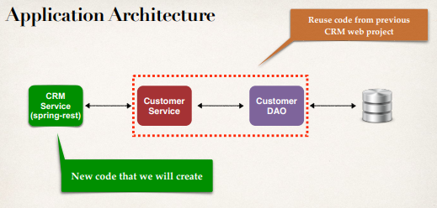

**Project Set Up**:

* We will download a Maven starter project
* Includes **CustomerService, CustomerDAO**, and Customer Entity
  + We created all of this code already
* Allows us to focus on creating CRM REST Service

**Development Process (Step-by-Step)**:

1. Get customers
2. Get single customer by ID
3. Add a new customer
4. Update an existing customer
5. Delete an existing customer

63.1. Spring REST - CRUD Database Real-Time Project - Overview